**EXPERIMENT 4(Non Isolated Topology of Choppers)**

**14BEE030**

Circuit Diagram Step Down Chopper using Time Ratio Control

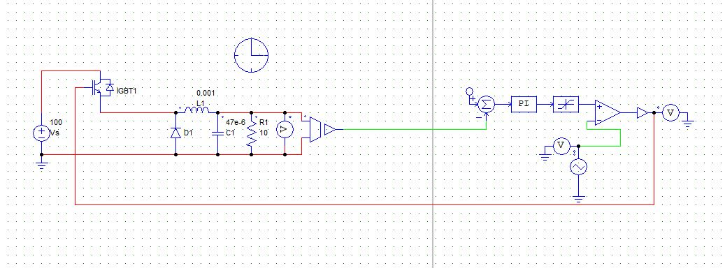Output Voltage Waveform of Step Down Chopper using Time Ratio Control

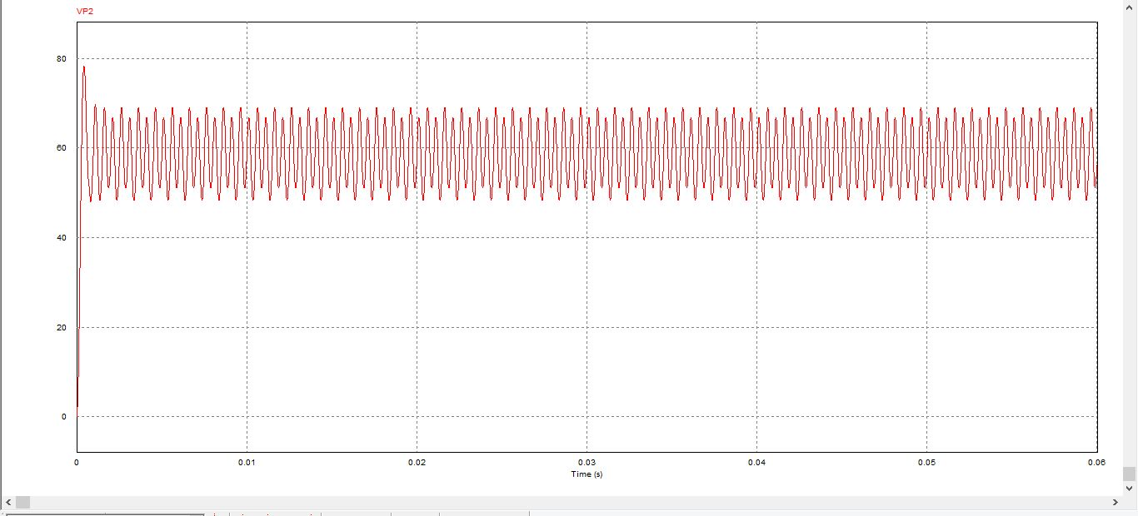

Circuit Diagram Step Down Chopper using Current Limit Control:-

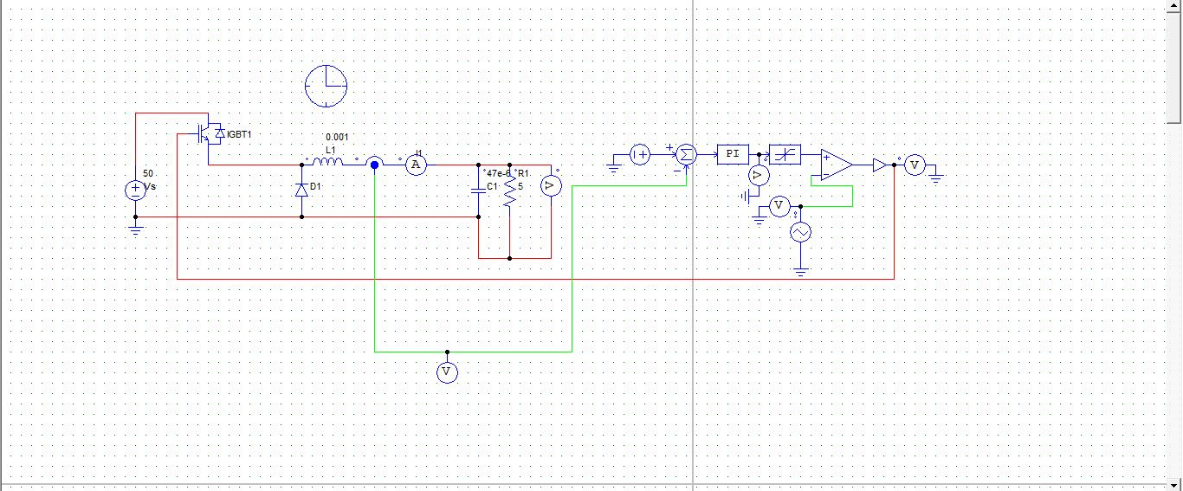

Output Voltage Waveform of Step Down Chopper using Current Limit Control:-

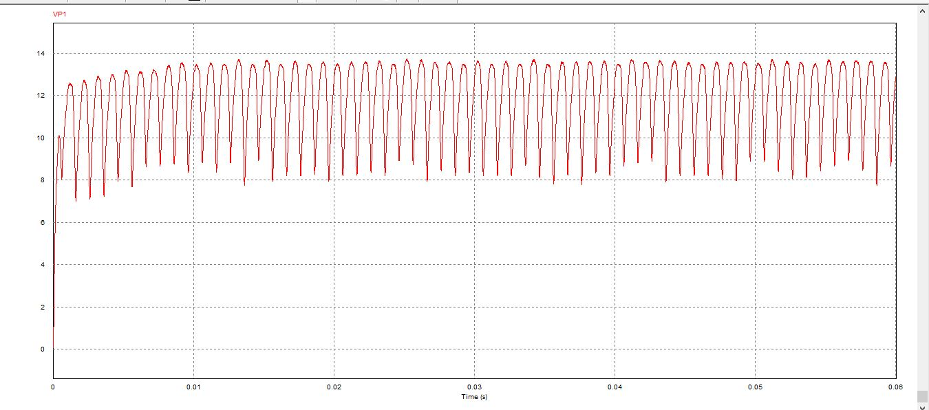

Output Current Waveform of Step Down Chopper using Current Limit Control:-

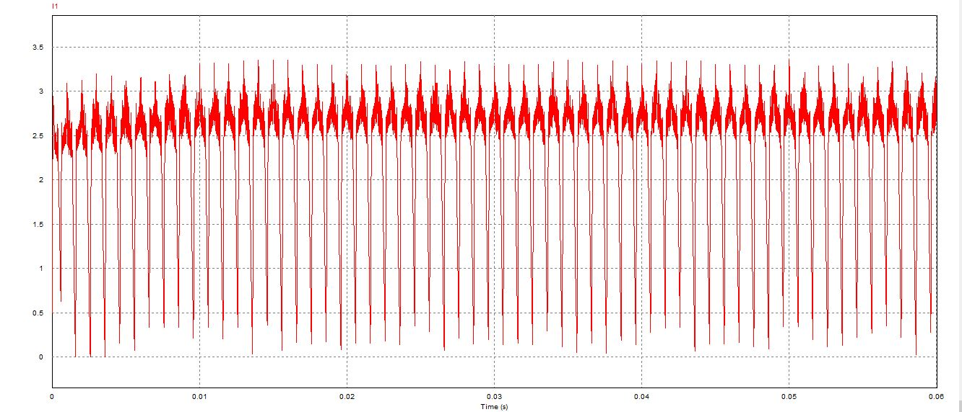

Circuit Diagram of Buck Boost Chopper:-

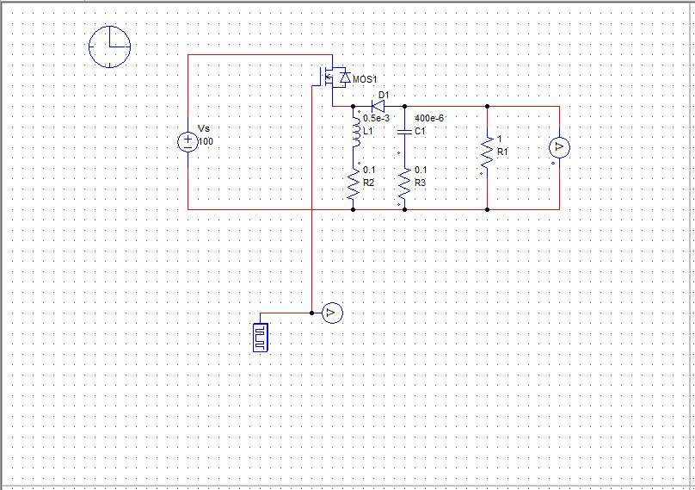

Output Voltage Waveform and gate pulse waveform for Boost operation:-

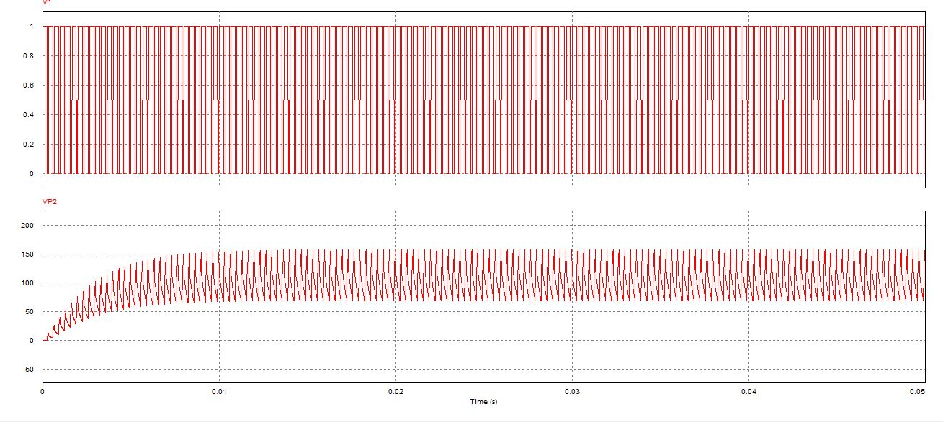

Output Voltage Waveform and gate pulse waveform for Buck operation:-

